Nagios Home Setup

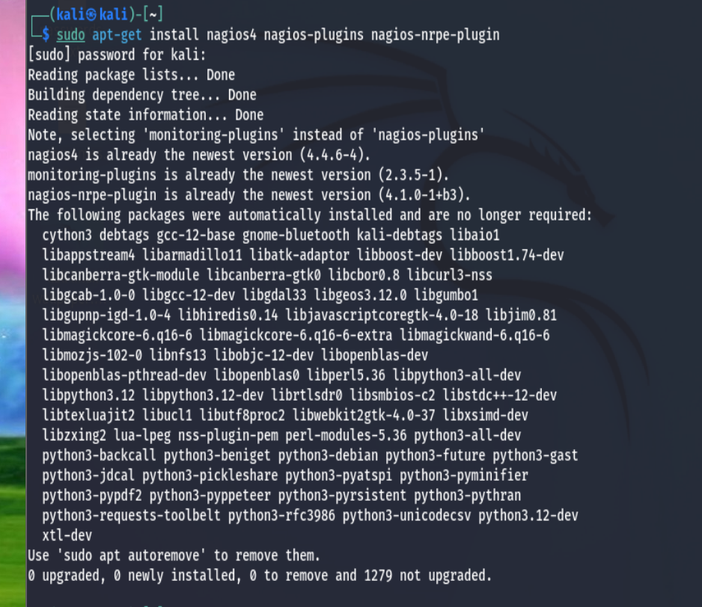

The first task I did for this project was install Nagios on my Kali Linux VM. The command that installed it was **sudo apt-get install nagios4 nagios-plugins nagios-nrpe-plugin**.

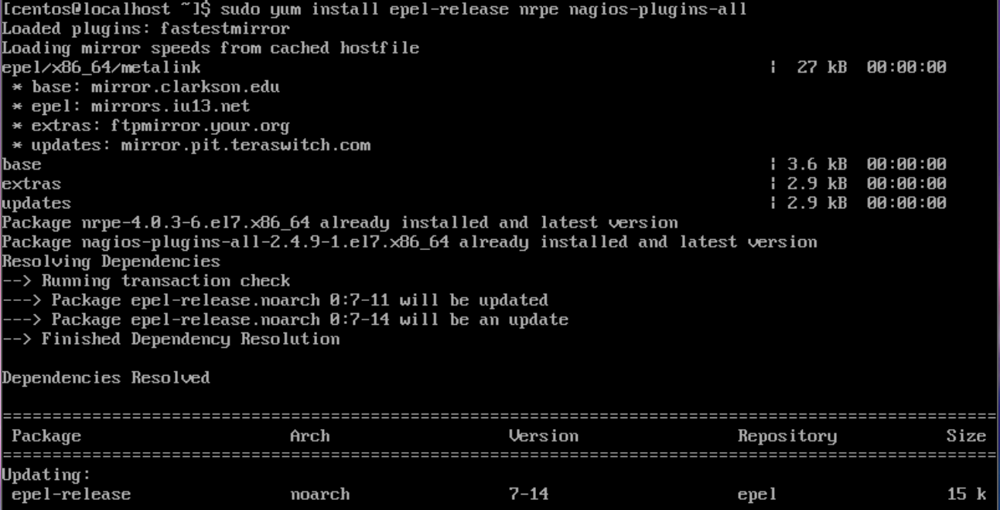

Then I installed Nagios on my CentOS 7 VM. The command to install it on CentOS was **sudo yum install epel-release nrpe nagios plugins-all**.

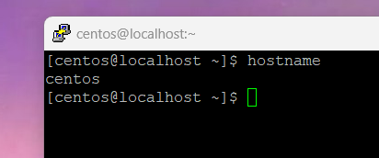

After I installed Nagios on CentOS, I put my VM into host-only mode so I can SSH into it with PuTTY. I then changed my hostname to ‘centos’. The command to change my hostname was **sudo hostname set-hostname centos.** The command **hostname** verifies the new name.

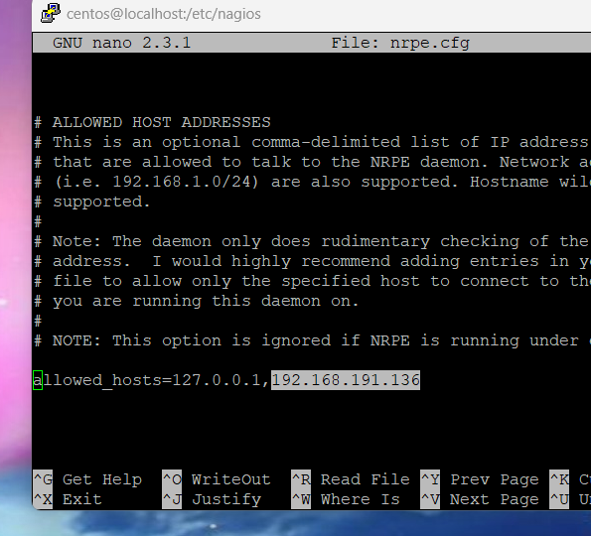

Then in CentOS, I navigated to the Nagios directory within the Etc directory. **cd /etc/nagios** was the command that got me there. When I was in the directory, I opened the nrpe.cfg file by typing **sudo nano nrpe.cfg**. I had to scroll a bit until I got to the “allowed host addresses” section. Where it says “allowed_hosts….”, I added the IP of my Kali Linux machine, being 192.168.191.136.

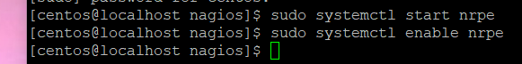

I then started and enabled the service by typing **sudo systemctl start nrpe** and **sudo systemctl enable nrpe**.

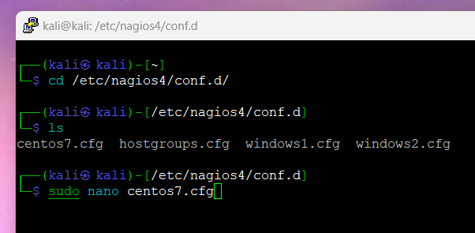

Then I put my Kali machine into host-only mode, and SSHed into it with PuTTY. After I did that task, I navigated to the conf.d directory within the Nagios directory by typing **cd /etc/nagios4/conf.d/.** I then typed **sudo nano centos7.cfg** which created the configuration file for CentOS.

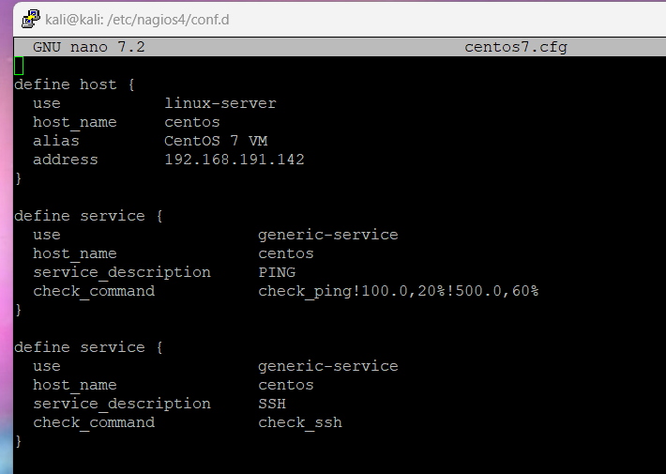

I added these lines to the configuration file. Where It says “host_name” in each section, I changed that to the hostname of my CentOS machine, being “centos”. The address section in the “define_host” section, I assigned my CentOS IP address to, being 192.168.191.142.

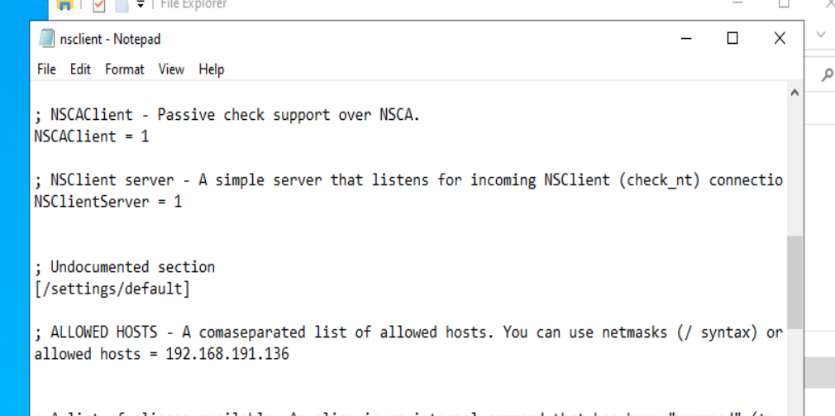

Next, in both Windows Server machines, I installed NSClient++. Once I installed it, I opened the nsclient configuration file as shown above, and I made sure the “ALLOWED HOSTS” section had my Kali IP address there, being 192.168.191.136.

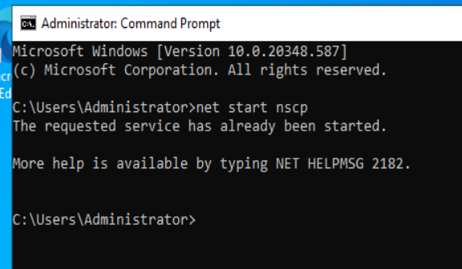

Then, I ran CMD as administrator, and I typed **net start nscp** to start the NSClient++ service.

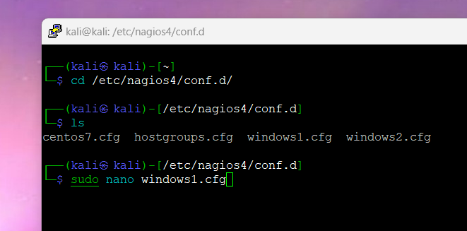

Back to Kali, in the conf.d directory I created the centos7.cfg file, I created a windows1.cfg file for one Windows Server machine by typing **sudo nano windows1.cfg**.

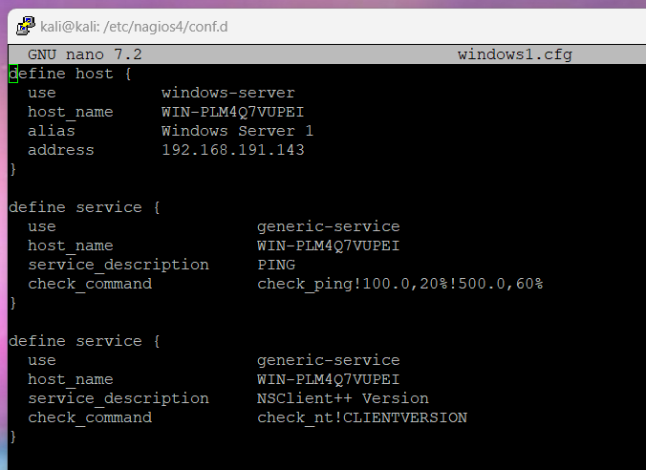

I made the file look like this. For this Windows machine, the host_name I changed to WIN-PLM4Q7VUPEI. The IP address in the “define host” is the IP of one my machines, being 192.168.191.143.

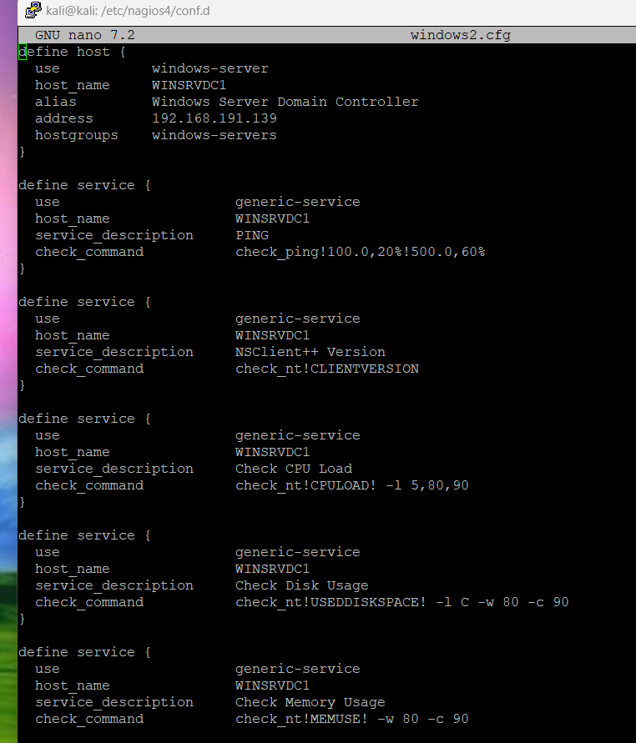

After saving the first configuration file, in the same conf.d directory within /etc/nagios4, I created my second configuration file by typing **sudo nano windows2.cfg**. The hostname for this machine is WINSRVDC1. The IP address of this machine is 192.168.191.139. I then saved the file.

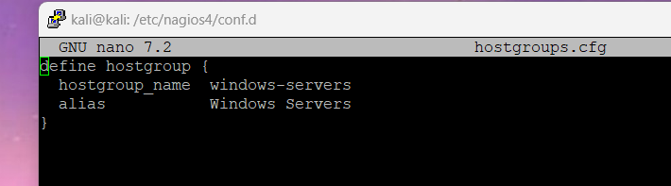

In the same conf.d directory within /etc/nagios4/, I had to create a hostgroups configuration file by typing **sudo nano hostgroups.cfg**. I made it look like this. The hostgroup name for my windows machines are windows-servers, the alias being Windows Servers.

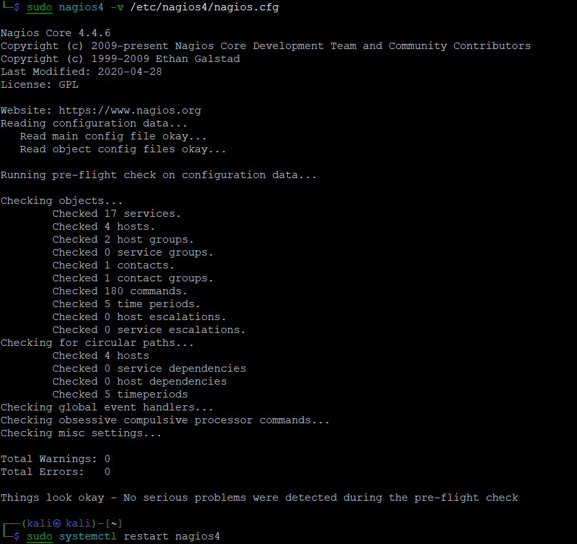

After making all my configuration files, I changed out of the directory by typing **cd**. Then I typed **sudo nagios4 -v /etc/nagios4/nagios.cfg** to make sure the service can run and that there are no errors in my configuration files. Then I restarted the Apache web service by typing **sudo systemctl restart nagios4.**

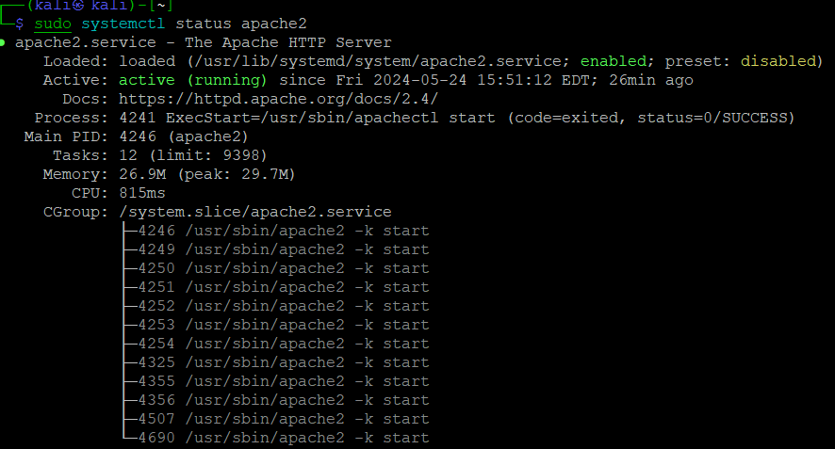

I then checked the status of Apache by typing **sudo systemctl status apache2** to make sure it was running.

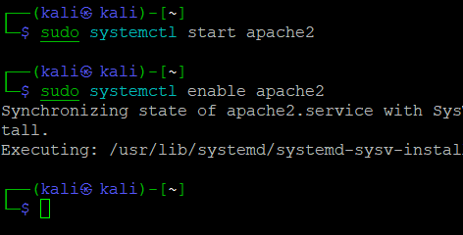

Then I started and enabled the Apache service by typing **sudo systemctl start apache2** and **sudo systemctl enable apache2.**

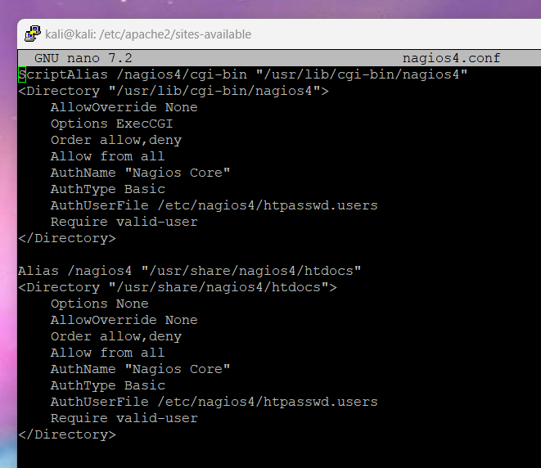

I then had to change directories into sites-available directory with etc and apache2. The command I typed to navigate to this directory was **cd /etc/apache2/sites-available.** I then had to make a Nagios4 configuration file by typing **sudo nano nagios4.conf.** I made it look like this, then I saved the file.

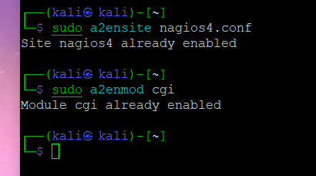

Then I needed to enable the Nagios website and the cgi module by typing **sudo a2ensite nagios4.conf** and **sudo a2enmod cgi.**

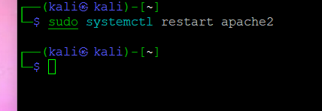

Then I restarted Apache by typing **sudo systemctl restart apache2.**

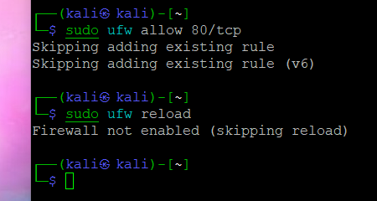

Next, I configured the firewall settings to allow HTTP by typing **sudo ufw allow 80/tcp** and **sudo ufw reload.**

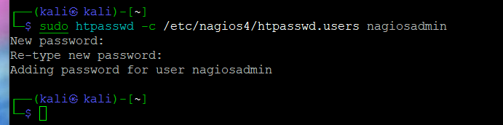

I then created a user for Nagios named nagiosadmin by typing **sudo htpasswd -c /etc/nagios4/htpasswd.users nagiosadmin.**

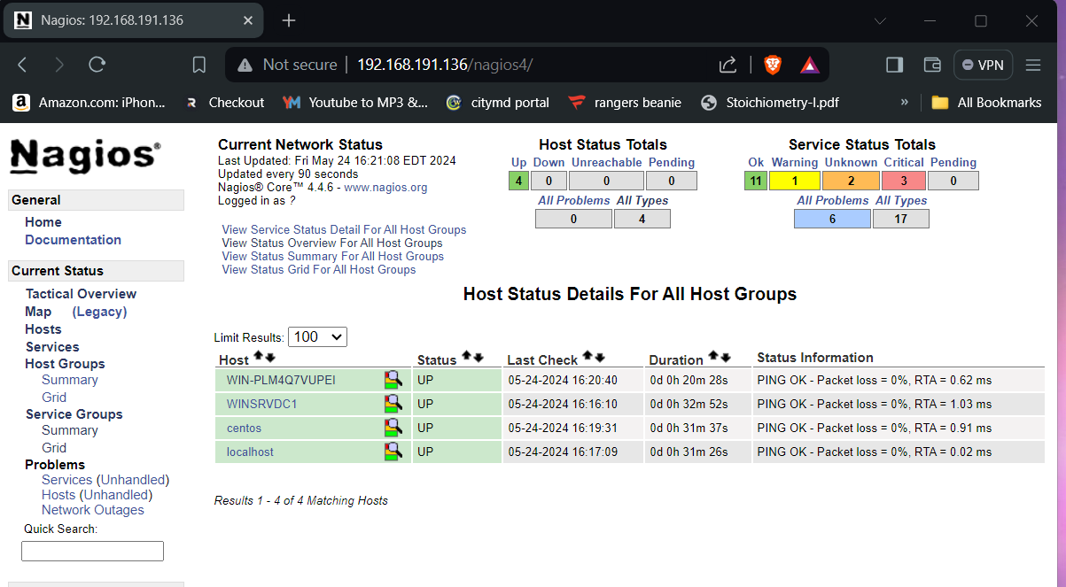

When going to my local browser, I typed in the IP of my Kali machine, then backslash nagios4, so **192.168.191.136/nagios4**, which brought me to this page, that tells me Nagios is up and running!

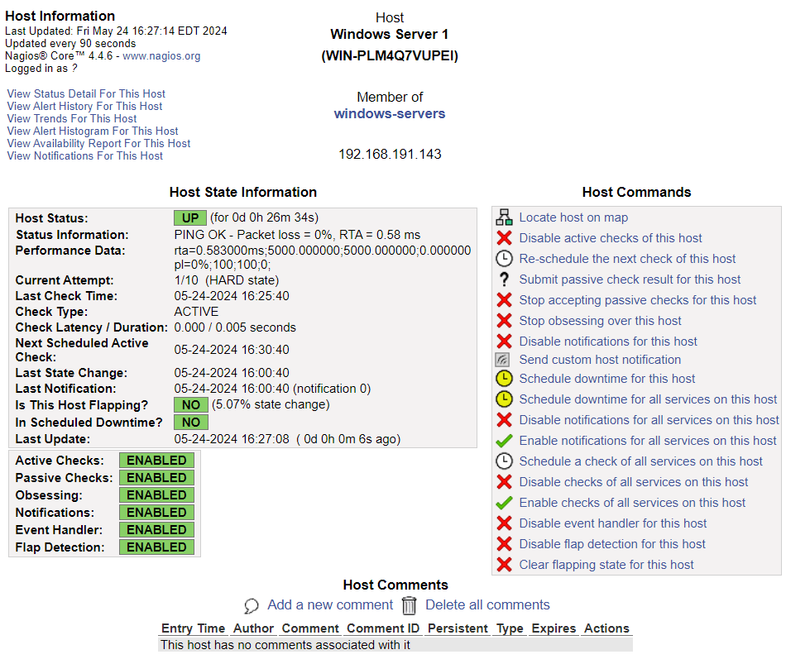

This is the summary of my first Windows Server machine. It is up and running with an RTA of 0.58 ms and there is no packet loos. Every 5 minutes, it undergoes checks. The active and passive checks, flap detection and notifications are enabled on this machine.

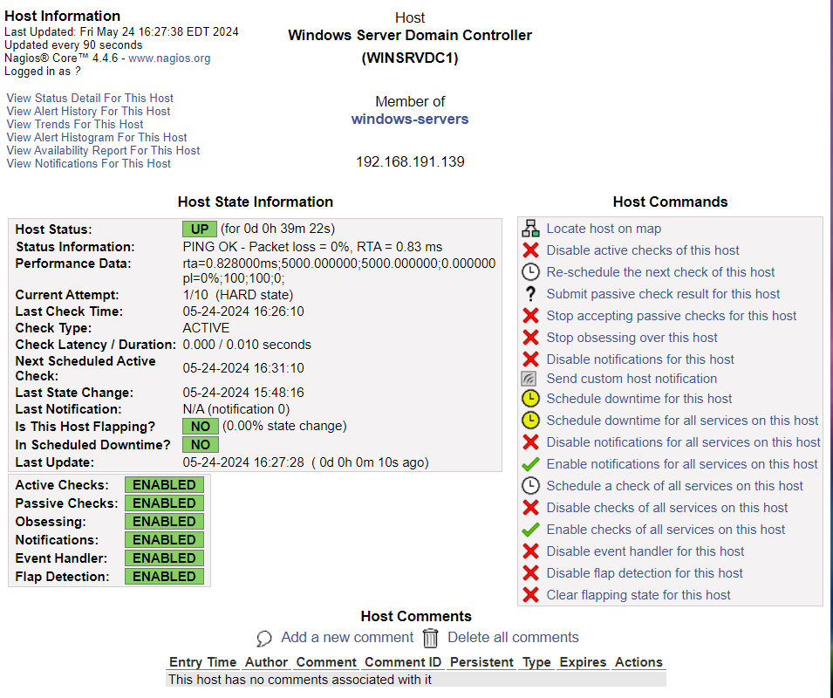

This is the summary of my Domain Controller and or second Windows Server machine. The machine is up and running too with an RTA of 0.83 ms and no packet loss. All capabilities for monitoring are enabled.

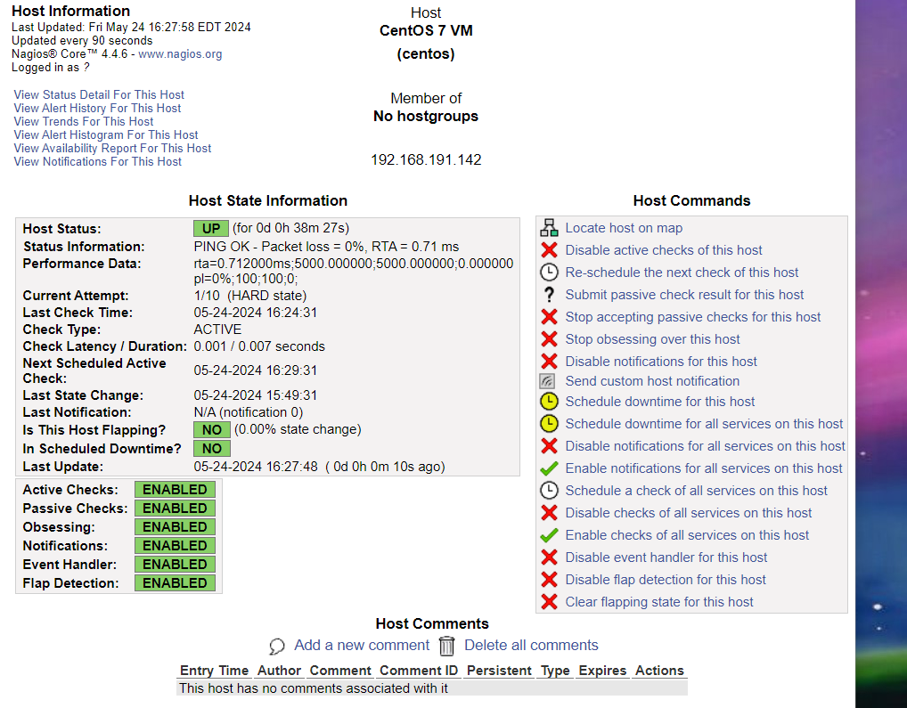

This is the summary of my CentOS machine. Its RTA is 0.71 ms and there is no packet loss. Every 5 minutes active checks are performed, and the system state is stable with no changes in state. Notifications, flap detection and active checks are enabled.

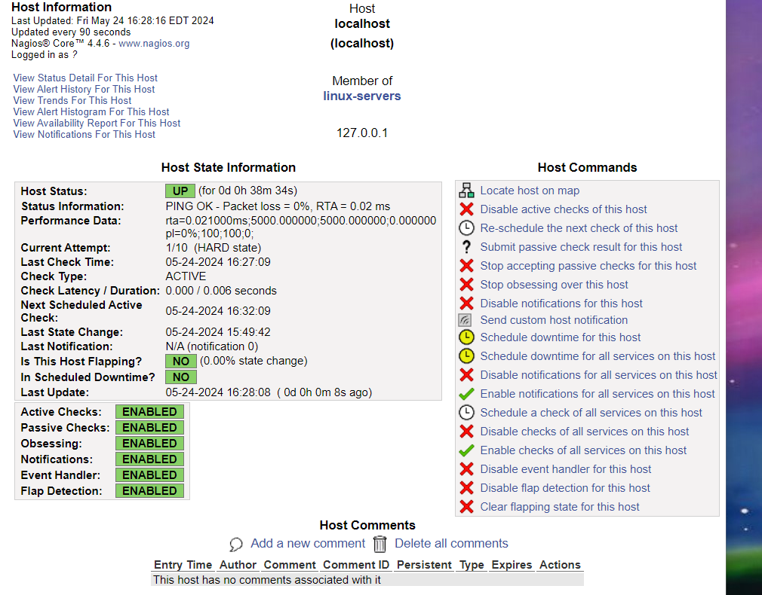

This is the summary of the localhost machine or the Kali Linux machine. This has a lower RTA of 0.02 ms. Every 5 minutes active checks are scheduled. There are no recent changes in state or notifications. All monitoring options are enabled.